|  |  |  |  |
| --- | --- | --- | --- |
|  | | | |
| **Expt. No:** | | **6** | **High Pass and Low Pass Filter Circuit** |
|  | | |
| **Date:** | **01/08/21** | |
|  | | | |

Name: Krishna Pandey

Adm no: U20CS110

**Aim:** (A) To implement Low Pass Filter circuit to plot its frequency response characteristics and Integrator.

(B) To implement High Pass Filter circuit to plot its frequency response characteristics and Differentiator as wave-shaping circuit

**SOFTWARE TOOLS / OTHER REQUIREMENTS:**

1. Multisim Simulator/Circuit Simulator

# Theory:

**RC – High Pass Filter:**

High pass filter is a circuit which passes only High frequency signals and rejects low frequency signals. The below figure shows the diagram of High pass RC circuit.

At Zero frequency the capacitor offers high amount of reactance hence as the capacitor is at the input it acts as a blocking capacitor. This circuit acts as capacitive coupling circuit and provides dc isolation between input and output. At high frequency capacitor offers less amount of reactance and a small amount of signal appears across the capacitor. Hence almost all the input applied appears across the output i.e. gain is unity.



High Pass Filter- Circuit and Frequency Response

Frequency Response of High Pass Filter

The response curves with respect to frequency and the capacitive reactance are given below



This response curve shows that the high pass filter is exactly opposite to the low pass filter. In high pass filter till the cut off frequency all the low frequency signals are blocked by the capacitor resulting in the decrease of output voltage. At the cut off frequency point the value of the resistor ‘R’ and the reactance of the capacitor ‘Xc’ are equal thus the output voltage increases at a rate of -20 dB/decade and the output signal levels are -3 dB of the input signal levels.

**RC – Low Pass Filter:**

Low pass filter is a circuit which passes only low frequency signals and attenuates high frequency signals when passed through a network over certain cutoff frequency and it is determined by the RC time constant. The below figure shows the circuit of Low pass RC circuit. Here we are going to discuss about different types of input signals given to the low pass circuit and observe the output response.



Determination of Cut-off Frequency:

A simple Low pass RC circuit consists of a resistor and capacitor across the input and capacitor across the output. As we know that a Capacitor exhibits Reactance (opposition to the flow of alternating current). By analyzing the low pass RC circuit at zero frequency the capacitor offers high amount of reactance almost acts as an open circuit. Now the entire signal passes across the output terminals hence the signal is unattenuated. We can say in terms of frequency response as the gain is unity at zero frequency. Similarly at high frequencies we can say that the capacitor offers less amount of reactance and hence the output decreases as frequency increases. This concept can be clearly understood by considering the following notations.



Where *Xc=Capacitive reactance measured in ohms, f = frequency in hertz, C = capacitance in farad*.

When f = 0

***Xc = ∞*** *(Open Circuit)*

***Xc = 0*** *(Short Circuit)*

Frequency Response:

It is defined as the plot drawn between magnitudes of output voltage versus frequency. It defines the range of frequencies for which the circuit is operated.



**Low Pass as an Integrator:**

In order to act circuit as an integrator it depends upon the time constant of the RC circuit .The time constant should be large enough when compared with the input signal so that the capacitor charges slowly and all the input voltage which is applied appears across the resistor. In this circuit the output is an integral function of the input voltage. In other words we can say that output is directly proportional to the input signal.

Applications of Integrator:

* To analyze the signals and perform the integration.
* To convert a square wave input into a triangular wave
* To convert a rectangular wave input into a saw tooth wave.



**High Pass as a Differentiator:**

The high pass circuit acts as a differentiator depending upon the time constant of the RC network. It varies depending upon the circuit. The time constant of the circuit should be small so that the capacitor charges quickly and all the voltage is taken by the capacitor and small amount of voltage appears across the resistor. The current in the circuit is decided by the capacitance.

The output equation in terms of capacitance is given by:



Applications of Differentiator:

* It converts triangular wave into square wave.
* It converts ramp input into step wave
* Generates spikes from square or triangular waves which are used in for triggering the circuits or for synchronization of clock circuits.



# Simulation screenshots

# Circuit Diagram of RC – High Pass Filter

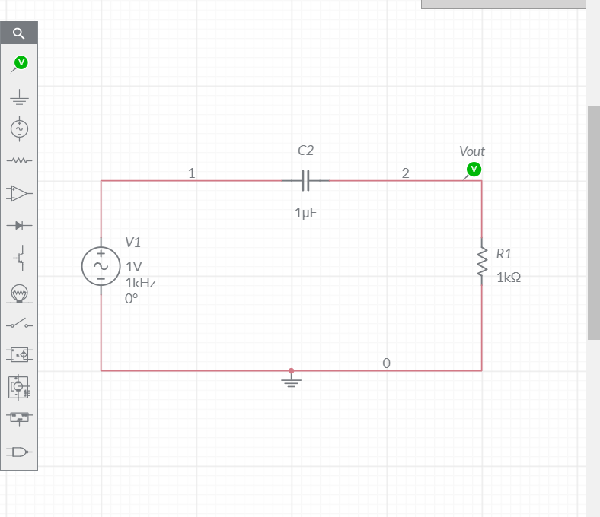

(Input – Sine Wave)

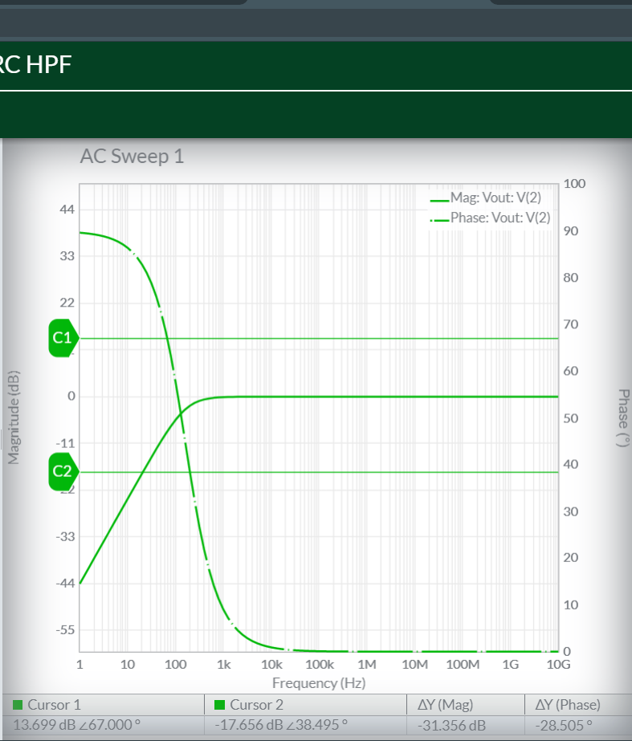

Frequency Response Plot of High Pass Filter

# Circuit Diagram of RC High Pass Filter as a Differentiator:

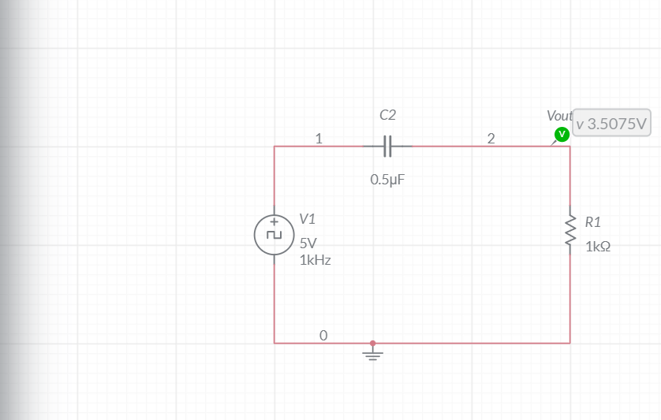

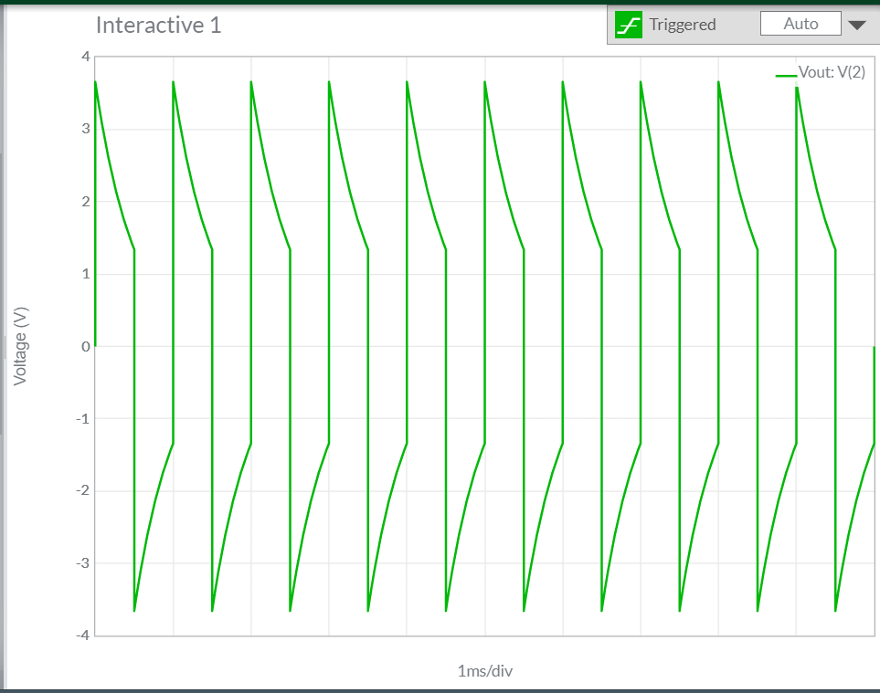

Output graph of HPF Circuit as a Differentiator

**Circuit Diagram of RC – Low Pass Filter:**

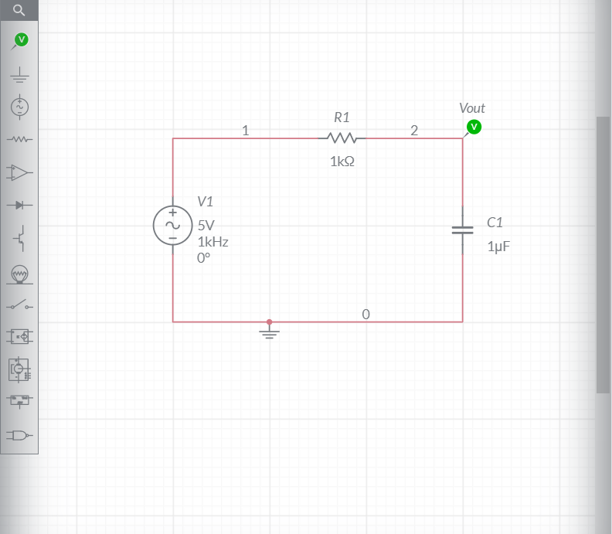

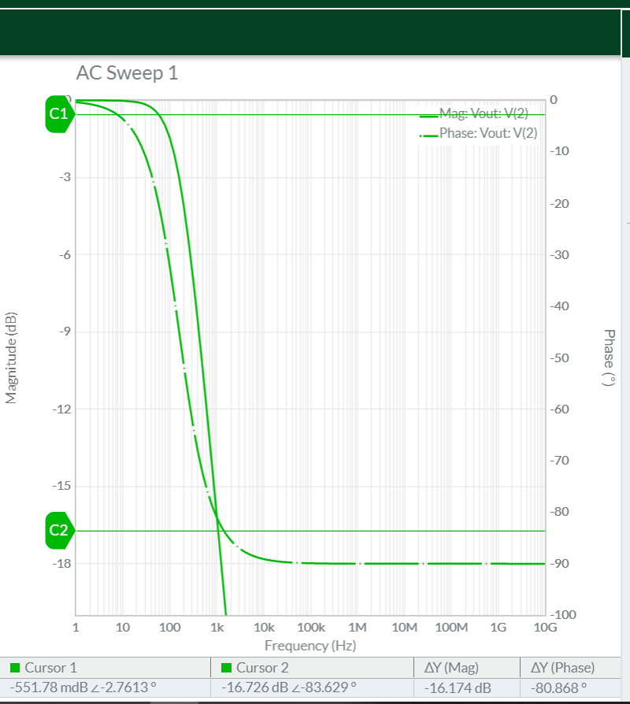

Frequency Response Plot of Low Pass Filter

**Circuit Diagram of RC Low Pass Filter as a Integrator:**

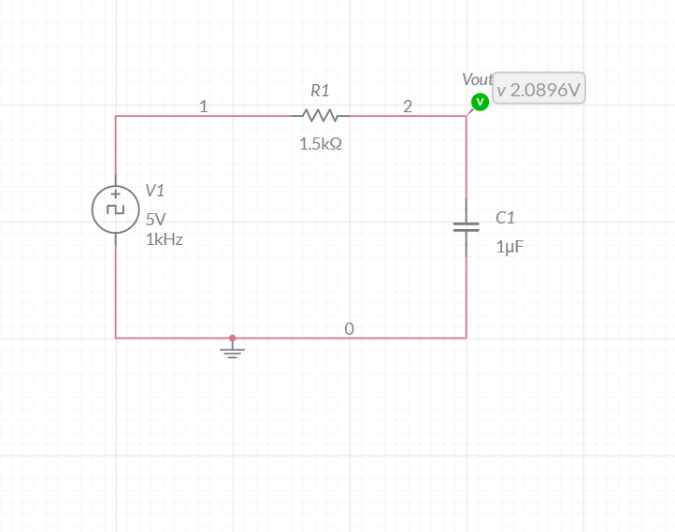

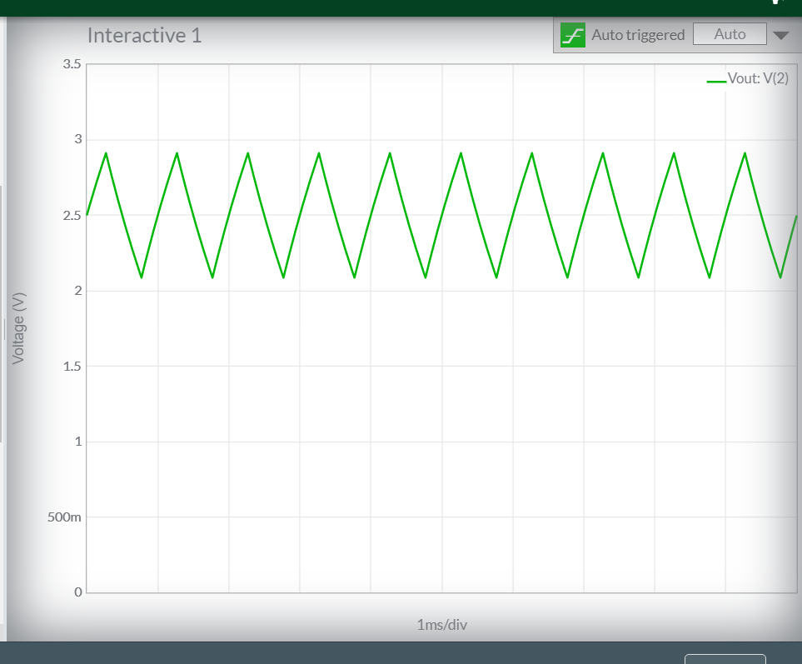

Output graph of LPF Circuit as a Integrator

**Conclusions**

Thus, we successfully implemented RC- High pass as well as Low pass circuit Using Multisim online and obtained the Frequency at -3dB in both the cases.

Also verified the waveform graphs for RC – Low Pass Filter circuit as Integrator and for RC – High Pass Filter circuit as Differentiator.